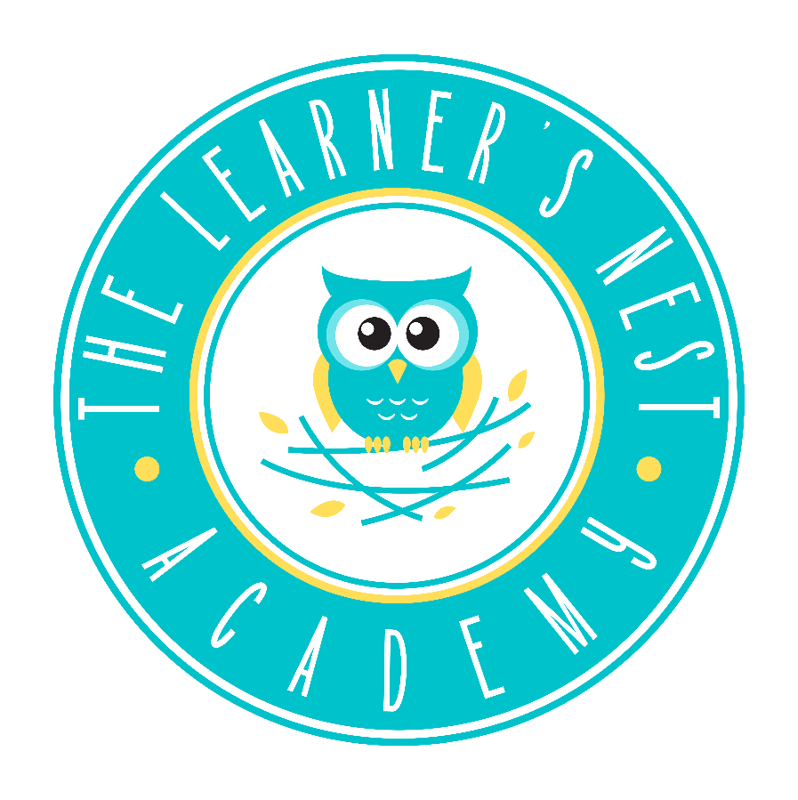

17214 Red Oak Dr.
Houston, TX 77090
346-235-3268
childcare@thelearnersnestacademy.com

Operational Policies and Procedures
Parent Handbook

We are so excited to have you and your little one apart of The Learner’s Nest Academy! We would like the thank you for choosing The Learner’s Nest Academy as you nurturing nest away from home. We know and understand how choosing a childcare center for your child is one of the most difficult and important decisions that you will make.

We want to assure you that you have made a great choice. One of the best ways to support our families is to surround them with fellow parents who “get it.” Our program is MOM operated and MOM approved.

Our program was founded on three core values: Integrity, Family and Future. Our team is composed of Early Childhood Professionals who encompass these values. We will assert 100% of our efforts to prove a safe, fun and quality environment for your child.

The following material and information will hopefully provide you with a better perspective about our program, commitment, and philosophies. We look forward to working with you to provide the best program for your child.

WELCOME TO THE LEARNER’S NEST ACADEMY FAMILY

Sincerely,
Eboni Curtis
Executive Director

CONTACT
Office 346-235-3286
Email childcare@thelearnersnestacademy.com

HOURS OF OPERATION
The Learner’s Nest Academy is a year-round program. We are open Monday – Friday from 05:30 a.m and close at 08:00 p.m. Instructional time starts at 8 a.m. daily.

Students must arrive by 9:30 a.m. to receive care.

The Learner’s Nest Academy is closed in observance of the following holidays:
New Year’s Day - Martin Luther King - Good Friday - Memorial Day – Juneteenth - Independence Day - Labor Day - Thanksgiving - Day after Thanksgiving - Christmas Eve - Christmas

Note: Depending on the day Christmas falls on we may be closed the entire week.

The Learner’s Nest Academy will close early on:
Day before Thanksgiving - 2-3 Training Days a Year

THE LEARNER’S NEST ACADEMY PHILOSOPHY
All students, regardless of gender, age, race, and/or physical limitations can and will learn up to their potential and will use the skills and knowledge learned to become well-rounded, well-educated, independent members of society.

MISSION STATEMENT
The Learner’s Nest Academy provides a nurturing and safe environment for children to enjoy developmentally appropriate play and learning experiences while preparing for the future.

OUR GOAL
It is our goal to assure parents that their children will be in a safe, healthy environment where staff will strive to meet emotional, social, and physical needs. We strive to create a happy, warm and exciting environment that is inviting, comfortable, flexible, and manageable for the children

ENROLLMENT DOCUMENTS NEEDED
The Learner’s Nest Academy require documentation to be provided for each child prior to the first day of care. Those documents are:
- Completed Enrollment Application and Agreement
- Current Immunization Record/ Vision and Hearing Screening
- A Current Photo (this will be taken at the center. The photo is used for identification purposes only.)
- Doctor’s Statement
- Acknowledgement of receipt of handbook

It is the responsibility of the parents to notify the director in writing of any changes in phone number, address, person authorized to pick-up, insurance, and family physician. This information is required to ensure the safety of your child and to ensure that the center has the most current info.

DRESS CODE
Your child will be active both indoors and outdoors. Please dress them in comfortable, washable clothes that will adapt to food spills, paint, sand and water. Please label sweaters, jackets, caps, etc. All children must wear closed toe shoes at all times. Each child is required to keep a change of clothes, including underwear and socks, at the center in case of an accident.

Infants – 18 months:
- Must follow the above guideline for dress code.

Toddler – 5 year old (fulltime only)
- Must wear The Learner’s Nest Academy’s collared shirt.
- Must wear khaki or navy blue bottoms.
- Closed toe shoes.
- Jeans can be worn on Friday with The Learner’s Nest Collared Shirt or The Learner’s Nest T- Shirt.

PAYMENTS
Tuition is due on the FRIDAY before the following week. Parents have a 2-day grace period to pay in the parent portal. A late fee of $40 will be added for any payment received after Sunday. An additional late fee of $5.00 per day will be charged. If payment is not received by Monday morning your child will not be able to stay/return for care until payment including any additional fees incurred have been resolved. No exceptions.

All parents must sign up for the parent portal to make payments. In the event the portal is unavailable, credit, debit and cash payments will be accepted at the front desk. Checks are not an acceptable form of payment. Automatic payment set-up is available and preferred.

ACH Fees
A penalty of $40 will be assessed for each returned ACH. If returned ACH fees are not paid within five working days, childcare will be temporarily interrupted until payment is received. If two ACH transactions are returned, your account will be handled on a cash/debit card basis only!

LATE FEES
Late fees for late pick-ups will be $15 for the first minute and $1 PER MINUTE after the first minute. This amount will be added to your profile in the parent portal and must be paid within 2 days of the fee being accessed. This will be strictly enforced.

If your child has not been picked up within one hour of the center’s closing time, Children’s Protective Services will be notified.

VACATION POLICY
Full-time students who attend The Learner’s Nest Academy five days per week for six months or more are entitled one week vacation with no fee to parents. This is a week the students don’t come and The Learner’s Nest Academy doesn’t charge a fee.

To qualify the week must be requested in writing and approved. Otherwise, weekly tuition we be charged to hold the student’s spot and for the student to return.

Disaster Tuition
If a natural disaster occurs, tuition will be waived only for the full weeks we are closed.

ATTENDANCE
Each child is expected to attend daily and arrive on time for the educational program. Excessive tardies/absences may result in your child’s dismissal from the program. If your child is going to be absent, please call the center and let a staff member know ahead of time, if possible. If your child has 5 consecutive absences he/she may be dropped from the program. Please communicate with the center if your child will have an extended absence due to an illness. Other emergency absences will be dealt with on an individual basis and will be accepted or denied at the discretion of the center director.

Sickness, including COVID-19 does not constitute a prorated rate.

ARRIVALS/ DEPARTURES
All children arriving to the center must be brought into the center by an individual 18 and up. DROPPING OFF CHILDREN UNATTENDEDE IN THE PARKING LOT IS NOT ALLOWED! The child must be left in the care of a designated center employee and must be signed in upon arrival. DROPPING OFF All children leaving the center for the day must be signed out by the parent or authorized individual and the teacher must be notified. PLEASE BE PREPARED TO SHOW ID.

If an emergency arises and you will not be able to pick up your child by closing time, you MUST call and notify the center director as soon as you are aware of it. You must also make arrangements for someone on your Authorization List to pick up your child. The center must be notified in writing to add a person to the Authorized List.

WITHDRAWALS
If you plan to withdraw your child from the program please notify the center director at least two weeks ahead of time or as soon as you know when his/her last day will be. The director will then notify the teacher who will in turn prepare the class and your child for departure.

GENERAL NOTICES
General notices, announcement, calendars, menus and special bulletins will be sent via the parent portal. Notices will also be posted in the main entrance.

PARENT GRIEVANCE
We pride ourselves on open communication with parents. If you have a grievance, please bring it to the attention of the center director as quickly as possible so that it can be resolved expediently.

PARENT INVOLVEMENT
Your involvement in your child’s education is very important in his/her educational success. We encourage parents to become involved by keeping line of communication open and by participating in events and other center functions. Some other ways of becoming involved may include, but are not limited to:
- Meeting with teachers for formal or informal conferences.
- Sharing a special talent or activity with child’s class.
- Helping your child’s teacher prepare materials.
- Attending special events sponsored by center.

The Learner’s Nest Academy does not allow parent volunteering.

THE EDUCATION PROGRAM
The Learner’s Nest Academy will us a blended curriculum and best practices in the classroom. Literacy, math, science, art projects, music, storytelling, social-emotional development and physical development will be included in the curriculum. We realize that all children work and learn at their own pace. This learning will be guided and monitored by your child’s teachers.

A copy of the activity schedule will be posted in each classroom.

SPECIAL NEEDS
We will attempt to meet the needs of all special need students within our ability.
- Care Evaluation must be completed.
- Tuition will be based on additional staffing needs.
- All equipment, supplies, special food, medical supplies, speech supplement, physical therapy will be the responsibility of the parent.
- Periodic care evaluation will be done to ensure proper care of the child.

EVALUATIONS
Parent conferences may be requested by the parent or the teacher at any time during the school year. Academic and developmental reports are sent out quarterly through the parent portal. Reports are not sent during summer camp. Parents can expect routine and consistent progress reports from the student’s teacher outside of these routine evaluations.

These evaluations are helpful to both the teachers and the parents in assessing each child’s
level of development.

REST TIME
The Learner’s Nest Academy, in accordance with minimum standards, must provide a supervised sleep or rest period for all children 18 months and older in care for five or more hours.

A rest period is scheduled in each classroom each day to balance the active time. We, as adults, are aware that not all children will sleep. However, all children will be encouraged to lie down and rest during this time. Blankets, towels, and small pillows are permitted during the rest time. They must be labeled and laundered at the end of week. All blankets, pillows and towels will be sent home each Friday. Generally, nap time will be from 12:00pm – 2:00pm. The rest period will not exceed 3 hours. This schedule may be altered due to special programs, field trips, or programs.

PERSONAL ITEMS
We ask that you discourage your child from bringing his/her personal treasures such as toys, watches, rings, earrings, etc. to the center. The center ask that parents be sure children leave all electronic devices at home. All electronic devices will be confiscated and returned to the parent during pickup. We will not be responsible for replacement of lost, misplaced or broken personal items. Personal items may be requested by individual teachers for SHOW AND TELL. It will be up to the parent and child to decide whether to bring items at this time.

OUTDOOR PLAY
Fresh air and daily exercise are essential to early childhood growth. When the weather permits children will be taken outside daily. Please make sure that your child has appropriate clothing for the weather outside.

Sunscreen and Insect Repellent are allowed. Parent can send sunscreen or repellent to be used as needed.
At this time The Learner’s Nest Academy does not participate in water activities.

FIELD TRIPS
The Learner’s Nest Academy’s field trips are scheduled throughout the year to enhance the child’s learning experiences. Information about the field trip will be provided a minimum 3 days prior to the field trip. There may be a fee associated with the field trip.
- Parents will need to provide consent on the field trip permission form provided by the center.
- We do reserve the right to disqualify a child from a field trip.

IN-HOUSE EVENTS
A notice of in-house events will be posted at least 48 hours in advance when possible. The Learner’s Nest Academy will maintain a monthly newsletter as well as an activity board.

SPECIAL DAYS/BIRTHDAYS
We do allow birthday parties at the center. However, we request that parents give a 48 hour notice so the teacher can prepare. The allotted time for birthday celebrations is during snack time at 2:30 pm.

Holidays celebrated: Christmas, Thanksgiving, Valentines, Independence Day, Cinco de Mayo, President’s Day, Dr. King birthday and Juneteenth.

SCHOOL PORTRAITS
The Learner’s Nest Academy provides, for your convenience, a quality photograph program throughout the year. Photo opportunities may include individual portraits, holiday portraits, and class portraits at the cost of the parents. This is an optional cost for the parents.

TRANSPORTATION
We provide transportation to and from public schools designated by the center. Transportation agreements are signed once a year. Transportation pick up forms must be signed and filled at both the center and school. If your child(ren) will not be transported by the center to or from school you must notify the center in advance. Car seats are to be provided by the parents.

DISCIPLINE
The Learner’s Nest Academy will use positive reinforcers for behavior management purposes. Positive reinforcement, praise, redirection, and one-on-one guidance will be used to help children manage their behavior. However, if these methods are unsuccessful the child will be placed on the “Calming Chair” in the classroom. During this time your child will take a few moments to reflect on his/her inappropriate behavior. He/She will be given the opportunity to return to the group only after he/she complies with the adult’s redirection. If your child refuses the “Calming Chair”, he /she will be removed from the classroom and a documented phone call will be made to the parent. Behavior warning notices and behavior referrals will be given to the parent to be signed and returned. A student-parent conference will need to be held for persisting behavior issues. If a child bites or fights with another, they will be given a warning, if this persists then it can result in disqualification of service for that child. Our goal of discipline is to help the student become a good decision maker, problem solver and communicator.

ZERO TOLERANCE POLICY
Tobacco, drugs, alcohol and weapons will not be allowed on the center’s premises. Students and parents who violate this policy will be automatically dropped from the program. Obscene language, fights, and/or assaults will not be tolerated. Any student that violates this policy may be subject to a full one-day suspension from the center. Parents under the influence of drugs and/or alcohol will not be allowed on the premises and, if necessary, local law enforcement will be called.

SOCIAL MEDIA AND INTERNET POLICY
At The Learner’s Nest Academy, teachers, students, staff, and other center community members use social networking/media/internet (Twitter, Facebook, blogs, etc.) as a way to connect with others, share educational resources, log experiences, create educational content, enhance the classroom experience, and network within and outside of the center community.

If you do not wish for your child to be highlighted on social media or have access to our online education programs please let us know in writing.

NUTRITION SERVICES
All parents will need to fill out a food program application. This program will not be of any cost to the parents.

The Learner’s Nest Academy participates in the Child and Adult Care Food Program. We follow the USDA Food Guidelines and provide nutritious meals and snacks. Therefore, we ask you NOT to allow your child to bring outside food or drinks into the center unless requested by the center. The Learner’s Nest Academy is not responsible for the nutritional value of outside food items.

Please make sure you have notified us of any allergies your child has.

Mealtimes are:
Breakfast 6:30 a.m – 8:30a.m
Lunch 11:00 a.m- 12:00 p.m
PM Snack 2:00 p.m- 3:00 p.m
3:00 p.m- 4:00 p.m (School Age)
Supper 5:00p.m- 5:30 p.m (School Age)

BREASTFEEDING
Parents have the right to send breast milk or breastfeed while your child is in care. Please label all bottles/cups with the child’s first and last name.

A comfortable place within the class will provided to enable a mother to breastfeed while the child is in care.

FUNDRAISERS
The Learner’s Nest Academy will host two to four fundraisers per year for the betterment of the center. Parents will be asked to help sell or contribute to the cause.

HEALTH INSURANCE & RECORD REQUIREMENTS
We request a copy of your medical insurance for your child in case of an emergency. In the interest of your child’s health and that of the other children in the center, parents are required to submit the child’s most current medical and immunization records before your child’s first day at the center. These forms must be updated in compliance with state law. An emergency telephone number of the doctor and hospital of your choice is also required and must be completed on the enrollment form.

We must have a health statement on file for all children in care. Upon enrollment you may sign the health statement verifying that your child has been seen by a health care physician within the past year. However, a Health Care Statement from your child’s physician will be required within the required time from child care licensing (12 months) or they cannot remain in care until it’s completed. We encourage you to get this statement completed by your child’s physician within 90 days of enrollment.

The Learner’s Nest Academy DOES NOT require a current TB test, in accordance to the state. However, if the state requirement changes we will notify the parents.

ILLNESSES, ACCIDENTS, AND EMERGENCY CARE
Sick children with a fever, diarrhea or a continuous cough may not be brought to the center for care.

If your child becomes ill while in our care, you will be called immediately to pick them up, or make arrangements to have them picked up. Your child will be removed from the classroom and isolated until you pick him up.

If a serious accident occurs, an emergency vehicle will be called to transport your child to the hospital on your child’s enrollment form or the hospital selected by the emergency care professional.

MEDICATIONS
Unexpired medicine will be administered by a designated staff member as directed by the parent’s information and signature in the Medical Authorization Log. This information must be filled out daily. Staff will administer only dated, labeled prescription medication with that child’s name on it. Over the counter medication may be given if the proper form is completed.

ALLERGIES
If your child has any allergies, please make sure to fill out the Allergies form in the enrollment packet and discuss it with the center director so that we may take necessary precautions. A doctor’s note is required for all allergies. Allergies will be communicated to staff, teachers, and the kitchen staff.

If your child has been prescribed an Epi-pen, it is your responsibility to provide it to the center in case of an emergency.

ALLERGIC REACTION ACTION PLAN
If a child has an allergic reaction while at the center:
- Emergency medical support will be requested as needed.
- The Epi-pen will be administered if child has one prescribed on file.
- Parent will be notified.

COMMUNICABLE DISEASES
Childhood illnesses are a part of growing up. However, if an illness occurs affecting children in the center a letter will be posted of precautions to take, and parents will be notified and encouraged to consult their physician for further information. Children absent from the center due to a contagious disease may not return to the center without a signed release statement from a physician indicating that the child is no longer contagious. Parents should keep the center staff updated daily so that we may hold the child’s spot if he/she is going to return after the Illness. Also SEE COVID-19 Policy.

FIRE DRILL, SEVERE WEATHER, AND DISASTERS
The staff and children practice fire and severe weather evacuation and safety drills monthly. In case of fire, we will evacuate the premises and relocate to another location. All parents will be notified of our whereabouts as soon as possible. Fire and weather disaster evacuation routes are posted in each room.

EMERGENCY PREPAREDNESS PLAN
The Learner’s Nest Academy does have a comprehensive Emergency preparedness plan. A full copy can be provided if requested.
If an emergency develops such as severe weather, fire, physical damage to the building or any other situation that poses a threat to the safety of the children we will evacuate to a safe emergency point.

- Bammel Elementary School 17309 Red Oak Dr Houston, Tx 77090
- Orthopedic Center 17270 Red Oak Dr Houston, Tx 77090

Both of these locations are in walking distance from the center. During the evacuation we will take all necessary steps to ensure we have all children in care accounted for, notify the appropriate emergency authority including childcare licensing and notify parents.

Fire and Severe weather drills are conducted according to state and county regulations every 30 days. If there is an emergency and it becomes necessary to close the center parents will be notified to plan for early pickup. If there is inclement weather and it is determined that the center will not open parents will be notified via the parent portal, email and text messages. We will follow Spring ISD weather closings.

SECURITY
As a security measure we ask that you please bring your child all the way into the building, sign him/her in, and see that he/she is under the supervision of an adult before you leave. All visitors must check in with the front desk. No one will be allowed to be on the premises without permission. Our center is secured by a monitored security system with exterior and interior cameras; we also have a monitored fire system.

DAMAGES
Parents are responsible to pay for any damages to the center’s property caused by their child or themselves. This will include broken windows, doors, holes in the walls, damage to other automobiles or anything else that will cost more than $20 to repair or replace. This does not apply to breaking small toys that the children play with daily.

CHANGES IN POLICIES
If there are any changes in policy, parents will be given the change in writing.

TEXAS DEPARTMENT OF FAMILY AND PROTECTIVE SERVICES (DFPS)
The Learner’s Nest Academy operates under the Minimum Standards for Child Care Center. A copy of these Minimum Standards can be found at www.dfps.state.tx.us or in the director’s office. The DFPS website can also provide you with a childcare centers Licensing Inspection Report.
You can contact this office for question, to file a report, or report child abuse at:
2221 West Loop South
P.O. Box 16017
Houston, TX 77222-6017
713.940.300
CHILD ABUSE
The Learner’s Nest Academy will continuously participate in training to make us a premiere child care center. This includes required training about child abuse and neglect. We also share with parents how to reduce the risk of abuse and neglect, prevention of child abuse, and signs of abuse and neglect.

EQUAL OPPORTUNITY PROVIDER
The Learner’s Nest Academy is an equal opportunity provider. Enrollment packets are available and accepted without regard to race, sex, national origin, disability, religion or political belief. If you believe that you have been discriminated against by this center because of one of the above, you may file a complaint against this center by calling or writing to the Civil Rights Department, PO Box 149030, Austin, Texas 78714-9030, 512-438-4313. USDA, Director- Office of Civil Rights 202-720-5964.

TEXAS PENAL CODE
Under the Texas Penal Code, any area within 1000 feet of a child center is a gang-free zone, where criminal offenses related to the organized criminal activity are subject to harsher penalty.

WEAPONS POLICY
The Learner’s Nest Academy provides a safe and nonviolent environment for our students, parents, and staff. To ensure safety fire arms, darts, knifes, cap pistols will not be permitted at any time.

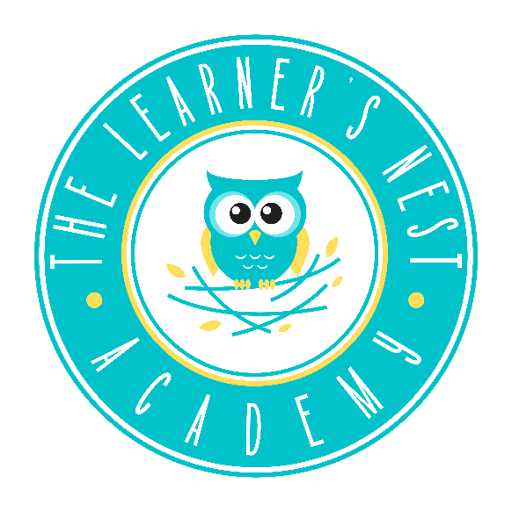

ACKNOWLEDGEMENT OF
RECEIPT OF HANDBOOK

I hereby certify I have read and fully understand the contents of The Learner’s Nest Academy Parent Handbook.
I also acknowledge that I have been given the opportunity to discuss any policy contained in this handbook with a company official. I agree to abide by the policies set forth in this handbook and understand that compliance to the rules and regulation is necessary for continued enrollment and employment.
My signature below certifies my knowledge, acceptance, and adherence to the company’s policies, rules, and regulations.
I acknowledge that The Learner’s Nest Academy has the right to modify or amend its policies at any time without prior notice.
Student(s) Name _______________________________________________________________________
Student(s) Name _______________________________________________________________________
Student(s) Name _______________________________________________________________________
Parent/ Employee Name _______________________________________________________________________
Parent/Employee Signature _______________________________________________________________________
Date _______________________________________________________________________

